You are tasked with the implementation of ANA*, as per.

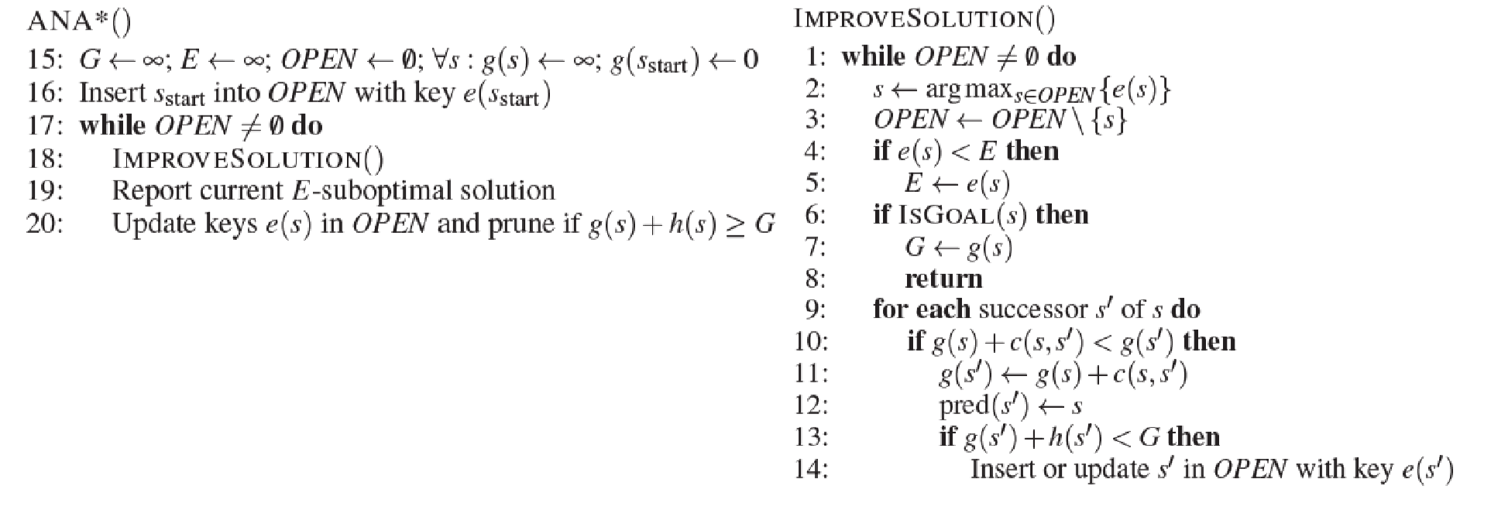

You have been given a [base_codePreview the document](https://canvas.wpi.edu/courses/15631/files/1880272/download?wrap=1) and some example mazes ([trivial.gif](https://canvas.wpi.edu/courses/15631/files/1880274/download?wrap=1), [medium.gif](https://canvas.wpi.edu/courses/15631/files/1880269/download?wrap=1), [hard.gif](https://canvas.wpi.edu/courses/15631/files/1880270/download?wrap=1), [very_hard.gif](https://canvas.wpi.edu/courses/15631/files/1880273/download?wrap=1)) to solve with your implemented search algorithm.  It is expected and required for you to provide some of your own searchable grid maps, in addition to those provided.

You are to provide a brief analysis of the performance of each solution, containing, at a minimum, the solution cost vs time.

Note:

* You can run the starting code with $ *python main.py trivial.gif*
* It is not necessarily plausible to solve all of the provided mazes with ANA*
* Your report quality will likely improve if you compare a more basic algorithm's performance against ANA*

Submission: code & report in .zip file